Project Development Phase
Performance Test

Date | 31 October 2026
Team ID | [Enter Team ID]
Project Name | Electric Vehicle Market Performance & Insights
Maximum Marks | —

Project Performance Testing:
Project team shall fill the following information in model performance testing template.
S.No. | Parameter | Screenshot / Values
 | Data Rendered | • Source: ev_market_train.csv (Kaggle EV Market dataset) – 200,000 rows × 37 columns, 46.5 MB, loaded as a Tableau extract.  • Published workbook size on Tableau Public: ≈ 11.2 MB.  • Values rendered: 1,550,703,961 total annual sales units across 15 categories, 200 manufacturers, 17,980 models, 10 manufacturing countries, 7 market regions, 5 battery types and 9 model years (2018–2026).
 | Data Preprocessing | • Train + test splits checked: 300,000 rows; 1 duplicate row / vehicle_id removed; text fields trimmed.  • Null values (train split): battery_cycle_life 3,786; resale_value_pct_3yr 6,103; infotainment_screen_inch 3,102; annual_sales_units 2,028; customer_rating 3,977 – imputed with group medians (battery type / category / manufacturer) and flagged (sales_imputed, rating_imputed).  • Derived fields: vehicle_segment, price_band, range_band, rating_band, revenue_usd, range_per_kwh, price_per_km_range, power_to_weight_kw_per_t → 0 nulls after preparation.  • manufacturing_country given Country/Region geographic role.
3. | Utilization of Filters | • % of Total Annual Sales – range slider (9.8211% – 10.7228%).  • Battery Type – filter / interactive legend (LFP, NCA, NMC, Sodium-Ion, Solid-State) applied to all sheets.  • Top 10 Manufacturers – Top-N filter by SUM(annual sales).  • Avg Customer Rating – continuous colour legend (4.04 – 4.14) on heatmap.  • Highlight / tooltip interaction across dashboard sheets.  All filters respond in under 3 seconds on Tableau Public.
4. | Calculation fields Used | • Total Annual Sales = SUM([annual_sales_units])  • Market Share % = SUM([annual_sales_units]) / TOTAL(SUM([annual_sales_units]))  • % of Total Annual Sales (percent-of-total table calculation)  • Avg Customer Rating = AVG([customer_rating])  • Avg Range (km) = AVG([range_km])  • Total Range = SUM([range_km]) by battery type  • Manufacturer Rank / Top-10 = RANK(SUM([annual_sales_units]))
5. | Dashboard design | No of Visualizations / Graphs – 8: Sheet 1 (sales by category), Top 10 Manufacturers, KPI Summary, Sheet 8 (rating heatmap), Sheet 6 (range by battery type), Sheet 4 (battery pie), Sheet 5 (avg range by category), Sheet 3 (sales trend by model year) + 3 filter/legend panels. Dashboard: ‘EV Market Executive Overview’.  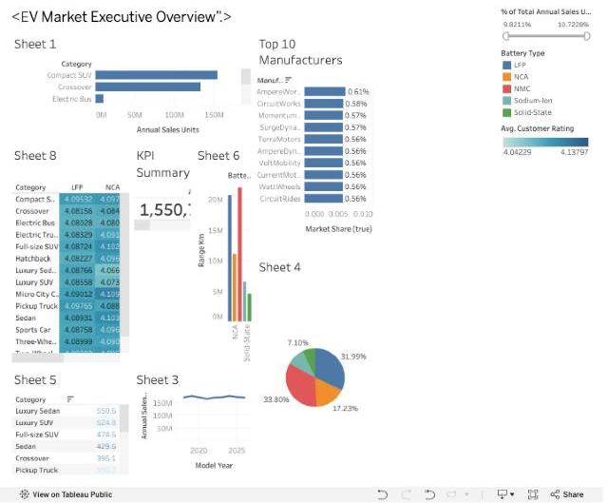
6 | Story Design | No of Visualizations / Graphs – 5 story points: (1) The Global EV Market at a Glance – full dashboard, (2) Battery Capacity and Driving Range – battery pie, (3) Charging Speed and Convenience – manufacturing-country map, (4) Pricing, Insurance, and Resale Value – range by battery type, (5) Sales Performance and Customer Satisfaction – rating heatmap.  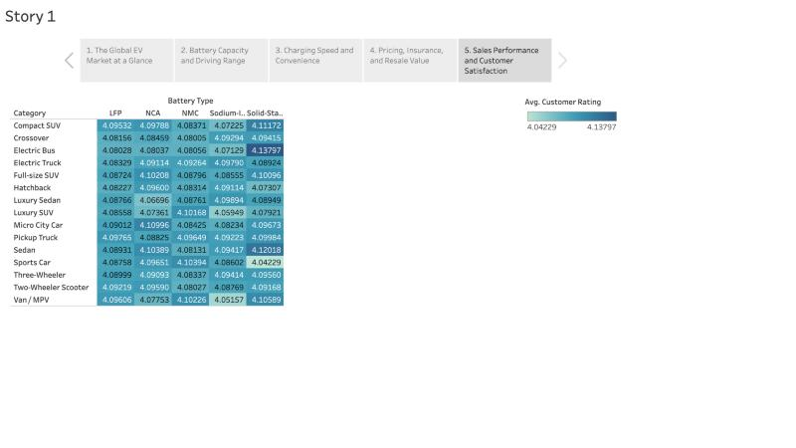

Performance note: An extract is used instead of a live text connection, row-level cleaning is done once in Python, unused fields can be hidden before extracting, and charts aggregate to category / battery / country level, so the dashboard and story render quickly on Tableau Public. Tableau’s Performance Recording (Help → Settings and Performance) can be attached for exact timings.

